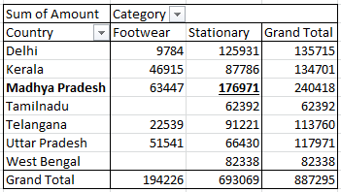Que.1) What is the total amount of stationary bought from Madhya Pradesh? Ans. – Rs. 176971/-

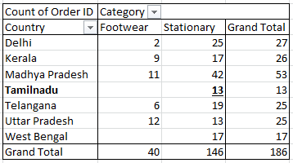Que.2) What is the total count of stationary bought from Tamilnadu? Ans. – 13

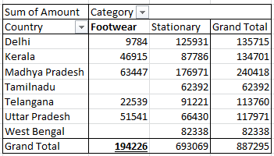Que.3) What is the total amount spent on footwear? Ans. – Rs. 194226/-

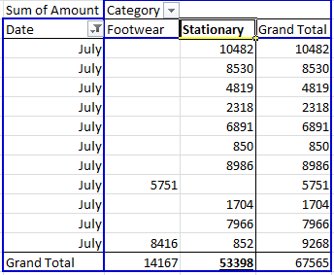Que.4) what is the total amount of money spent for stationary in July? Ans. – Rs. 53398/-

Que.5) What is the count of footwear that is coming from Delhi? Ans. – 2

